**What Is Web API ?**

ASP.NET Web API is a robust framework for developing HTTP-enabled service APIs that expose services and data. It may be accessed by a wide range of clients, including browsers, mobile devices, desktop computers, and tablets. Because it is an HTTP service, it may reach many clients.

**Why Do You Need Web API?**

* Web API allows access to service data from web browsers, mobile apps, and other devices.
* Web API aids in the development of lightweight, maintainable web services.
* Web API also supports [JSON](https://www.simplilearn.com/tutorials/python-tutorial/json-python), [XML](https://www.simplilearn.com/tutorials/programming-tutorial/what-is-xml), and other data formats.
* Web API helps develop services that support caching, request/response headers, versioning, etc.

## Features of Web API :

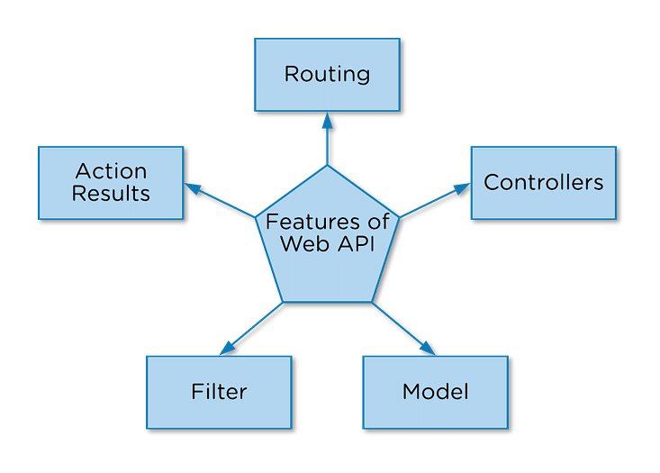

**There are five features of Web API, they are:**

1. [Routing](https://www.simplilearn.com/tutorials/asp-dot-net-tutorial/asp-dot-net-core): It helps in routing through different APIs.
2. Controller: It gives functional capabilities to the web application.
3. Model: It gives the structural capabilities to the web application.
4. Filter: It gives filters to the web application.
5. Action Result: It can keep the action logos user, such as data retrieval.

## ****Key HTTP Methods Explained :****

| **Method** | **Usage** | **Example Endpoint** | **Description** |
| --- | --- | --- | --- |
| **GET** | Retrieve data | GET /api/products | Returns all products |
| **GET** (by ID) | Retrieve single item | GET /api/products/1 | Returns product with ID=1 |
| **POST** | Create new item | POST /api/products | Adds a new product |
| **PUT** | Update item | PUT /api/products/1 | Updates product with ID=1 |
| **DELETE** | Remove item | DELETE /api/products/1 | Deletes product with ID=1 |

**Popular API Examples:**

1. **Google Maps API's:** Google Maps APIs allows developers to use Google Maps on Webpages using a JavaScript or Flash interface.
2. **YouTube API's:** Google's API lets developers integrate YouTube and functionality into websites or applications. YouTube APIs include the YouTube analytics API, YouTube Data API, YouTube live streaming API, YouTube Player APIs and others.
3. **The Flickr APIs:** It is used by developers to access the Flick photo sharing community data.
4. **Twitter APIs:** Twitter offers two APIs, the REST API allows developers to access core Twitter data and the search API provides methods for developers to interact with twitter search and trends data.

## Four types of web APIs :

APIs are broadly accepted and used in web applications. There are four different types of APIs commonly used in web services :

* **public**
* **partner**
* **private**
* **composite.**

### Public APIs :

 A public API is open and available for use by any outside developer or business. An enterprise that cultivates a business strategy that involves sharing its applications and data with other businesses will develop and offer a public API. These are also called open APIs or external APIs.

### Partner APIs :

A partner API, only available to specifically selected and authorized outside developers or API consumers, is a means to facilitate business-to-business activities. For example, if a business wants to selectively share its customer data with outside CRM firms, a partner API can connect the internal customer data system with those external parties -- no other API use is permitted.

Partners have clear rights and licenses to access such APIs. For this reason, partner APIs generally incorporate stronger authentication, authorization and security mechanisms. Enterprises also typically do not monetize such APIs directly; partners are paid for their services rather than through API use.

### Internal APIs :

An internal or private API is intended only for use within the enterprise to connect systems and data within the business. For example, an internal API might connect an organization's payroll and HR systems.

Internal APIs traditionally present weak security and authentication -- or none at all -- because the APIs are intended for internal use, and such security levels are assumed to be in place through other policies. This is changing, however, as greater threat awareness and regulatory compliance demands increasingly influence an organization's API strategy.

### Composite APIs :

Composite APIs generally combine two or more APIs to craft a sequence of related or interdependent operations. Composite APIs can be beneficial to address complex or tightly related API behaviors and can sometimes improve speed and performance over individual APIs.